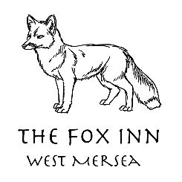

The Fox Inn

Application form

Application for bar/waiting staff:

Your details:

Name:

Address:

Postcode:

Phone:

Email:

Date of Birth:

Education and training:
Please give details:

Qualifications:
Please give details:

Employment history:

Your current or most recent employer

Name of employer:

Address:

Postcode:

Job title:

Pay:

Length of time with employer:

Reason for leaving:

Duties:

Please tell us what skills you have gained in this job:

Previous employers:
Please tell us about other jobs you have done and about the skills you used or learned in those jobs.

Supporting statement:
Please tell us why you applied for this job and why you think you are the best person for the job.

Interview arrangements and availability:
If you have a disability, please tell us if there are any reasonable adjustments we can make to help you in your application or with our recruitment process.

Are there any dates when you will not be available for interview?

When can you start working for us?

Do you have any holidays/events booked that you would need time off for?

Right to work in the UK:

Do you need a work permit to work in the UK? Yes / No

References:
Please give the names and contact details of 2 people who we can ask to give you a reference. We may ask them before an employment offer is made. We will not ask your current employer until we get your permission.

Referee 1

Referee 2

Declaration:
I confirm that to the best of my knowledge the information I have provided on this form is correct and I accept that providing deliberately false information could result in my dismissal.

Name:

Signature:

Date:

